Report for: | Cabinet
Date of Meeting: | 16 November 2023
Subject: | Electric Vehicle Charging Strategy: Draft for approval.
Key Decision: | Yes, affects multiple wards and over time will be significant in terms of its impact on our communities.
Responsible Officer: | Dipti Patel, Corporate Director for Place
Portfolio Holder: | Councillor Anjana Patel, Portfolio Holder for Highways, Infrastructure and Community Safety
Exempt: | No
Decision subject to Call-in: | Yes
Wards affected: | All
Enclosures: | Appendix 1 – Harrow Electric Vehicles (EV) Strategy 2038

Section 1 – Summary and Recommendations
This report presents a draft Harrow Electric Vehicles (EV) Strategy 2038 for approval.

Recommendations:
Cabinet is requested to:

- Approve the attached draft Electric Vehicles Strategy.

- Delegate authority to the Director of Environment, following consultation with the Portfolio Holder for Highways, Infrastructure and Community Safety, to make minor changes to the Electric Vehicles Strategy as and when necessary.

Reason: (for recommendations)
To provide a strategic framework for the Council and the Borough to enable the expansion of electric vehicle (EV) charging infrastructure on public assets for the benefit of Harrow residents, whilst contributing to the decarbonisation of transport in Harrow.

Section 2 – Report

Options considered

- Do nothing: this option is not recommended as this will not advance the Council’s and national government’s decarbonisation aims and will fail to support residents in the transition to electric vehicles.

- Agree the draft Harrow Electric Vehicles (EV) Strategy 2038 to provide a long-term strategic framework for action within the borough.

Background

The London Borough of Harrow wants to encourage the uptake of ultra-low emission vehicles through the use of promotional activities and the introduction of EV infrastructure. The council aims to improve air quality, reduce traffic noise and reduce CO2 emissions throughout the borough by expanding the availability of electric vehicle charging facilities to support the transition to ultra-low emission vehicles.
Until 2023, the Council’s focus has largely been providing chargepoints in locations requested by residents and/or businesses. However, there is now a requirement for a longer-term Strategy that aims to achieve a more ambitious roll out of publicly accessible chargepoints at scale, based upon underlying demand potential, alongside rapid charging hubs on the strategic road network and within town centres.

Purpose of the Strategy

The UK Government have prohibited the sale of new diesel and petrol-powered vehicles by 2035, with an interim requirement that at least 80% of new cars and 70% of new vans are electric by 2030.
In mandating the adoption of electric vehicle (EV) and other alternative fuel technologies to decarbonise the transport system, the UK government acknowledge the climate emergency and the requirement for comprehensive decarbonisation of the transport system, in order to support its overarching 2050 net zero target.
The Office for Zero Emission Vehicles (OZEV) has cited the pivotal role local authorities have in facilitating the uptake of EV and the development of publicly available EV chargepoint infrastructure.

To this end, Harrow’s EV strategy will facilitate the transition to EV and the provision of accessible and reliable EV chargepoints for everyone who lives, works and visits Harrow, while also meeting the long-term objectives of reducing overall car ownership and usage in the borough.

The draft Strategy looks beyond the present day, to the near future, and up to fifteen years until 2038. Given the highly evolving nature of the EV industry, it is recommended that once approved, the planned actions in the Strategy are revisited no later than 2030.
The Strategy consists of the following chapters:
Chapter 1 – Background & Purpose
Chapter 2 – EV Market Overview
Chapter 3 – Vision & Objectives
Chapter 4 – Forecast for EVCPs (Electric Vehicle Charge Points)
Chapter 5 – EVCP Location Assessment
Chapter 6 – EVCP Delivery Model
Chapter 7 – Action Plan

Overview of key draft Strategy messages

Current situation
There are currently about 3,500 EVs in Harrow, which is less than 3.4% of total registered vehicles in Harrow. However, the Council anticipates this will increase to about 20% in 2030, nearly 60% in 2038 and approaching 100% by 2050. EV penetration in Harrow currently trends with adjacent local authorities outside London. In addition, since the pandemic, EV penetration of new car sales has shown strong growth within the UK.
In addition to home-based charging solutions, Harrow currently has around 64 public chargepoints including 57 lamp column (3kW) and fast (7-22kW); and seven rapid (>50kW) chargepoints at both publicly and privately owned land in Harrow. In addition, the Council plans to deploy funds secured through the On-street Residential Chargepoint Scheme (ORCS) in delivering 225 additional lamp column chargepoints in 2023/24. Delivery of these additional chargepoints is focused on supporting residents who do not have access to off-street parking.

EV chargepoints
There is a range of different types of public EV charging infrastructure available across the market, alongside emerging technologies which are being trialled and piloted across the UK. There are several chargepoint options for users as to where, how and when they want to charge their vehicles. EV charging infrastructure can be split into four categories based on speed/power output:
- Slow
- Fast
- Rapid; and
- Ultra-rapid.

Harrow currently operates a mixed provision of chargepoints both on-street and in car parks. The council intends to keep a mixed provision of chargepoints for different use cases, so that there are a range of chargepoint options for residents.

EV forecast projection to 2038
The projection of EV penetration within Harrow shown below is based on:
- The penetration of EV within total new vehicle sales according to the trajectories defined in OZEV’s zero emission vehicle (ZEV) mandate; and

- The rate at which older incumbent diesel and petrol-powered vehicles age out as a function of average useful life estimates derived from Department for Transport (DfT) data.

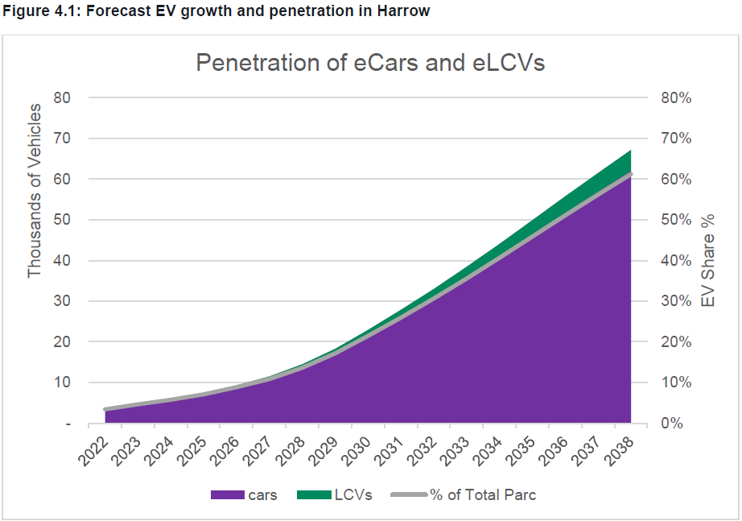

Source: Steer analysis
*eLCV – Electric Light Commercial Vehicles

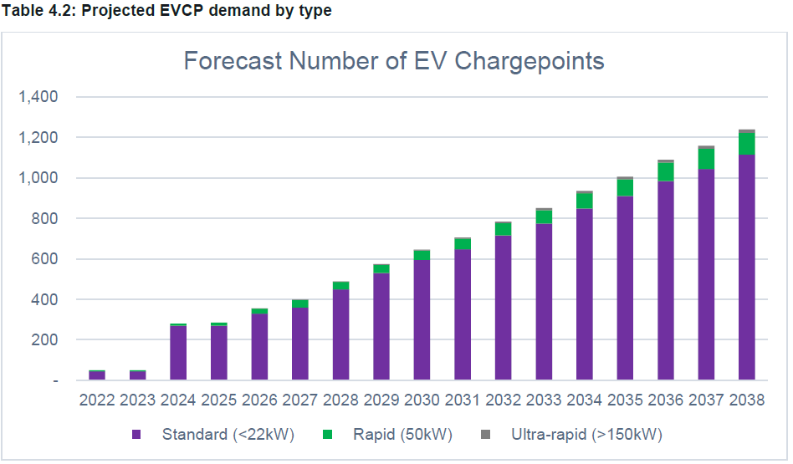

However, only a portion of the public charging network will be located on Council land (assumed to be 50%). The remaining EV chargepoints will be deployed on private land by project sponsors including supermarkets, other retailers and existing diesel and petrol sellers.

Potential locations for rapid or ultra-rapid charging
Key locations for potential rapid or ultra-rapid chargepoints (50-150kW) have been identified, considering both the key destinations across Harrow (i.e., locations with higher dwell time) and the availability of space to locate rapid chargepoints (either standalone or in bunch). These locations include high opportunity areas (e.g., retail, high street car parks, industrial areas and so on). These chargepoints will help meet the need of residents for top-up charging, as well as that of visitors, small businesses, taxi and private hire vehicle (PHV) drivers travelling into the borough.
It is anticipated that nearly half of the public charging network in Harrow will be located on Council land (including the public highway) and that the remaining chargepoints will be on private land (e.g., supermarkets etc). Development of charging infrastructure on Council land (roughly 700 chargers by 2030) will require a mix of funding from both public sources (e.g., the ORCS and Local Electric Vehicle Infrastructure (LEVI) programs) and private sources.

Key actions
A set of actions to meet the objectives of the Strategy in the short (2024-26), medium (2027-33) and long (2034-38) term have been developed. They are included in Chapter 7 of this Strategy.

Some of the key targets include:
- Ensure at least 10 rapid (50kW) and ultra rapid (>150kW) chargepoints are deployed on council land by 2026.
- Deliver up to 500 on-street chargepoints on council land by 2030.
- Ensure 80% of the residents in the borough have access to a chargepoint within 3 minutes walk from home by 2033.
- Develop a phased approach to the Council's own fleet electrification (as the existing vehicles reach end of life) and progress towards full fleet electrification by 2035.
- Ensure all new chargepoints deployed on council land meet the accessibility standards set out in BSI Electric vehicles - Accessible charging - Specification (PAS 1899:2022).
- Continue to provide emission-based parking permits in the Controlled Parking Zones (CPZs).

Implications of the Recommendation

Environmental Implications
Environmental implications are integral to the subject matter of this report.
The development of a decarbonised transport system that reduces and ultimately eliminates fossil fuel vehicle journeys has many environmental benefits including better air quality, reductions in noise pollution, increases in local biodiversity and healthier, more liveable streets.

Risk Management Implications

Risks included on corporate or directorate risk register? No

Separate risk register in place? No

The relevant risks contained in the register are attached/summarised below. Yes

The following key risks should be taken into account when agreeing the recommendations in this report:

Risk Description | Mitigations | RAG Status
Without a coherent Strategy Harrow will not have identifiable objectives. The Council would lack the focus required to achieve vehicle electrification at scale and enable the borough to meet its green mobility and decarbonisation commitments, providing the necessary charging infrastructure for the benefit of residents and businesses in Harrow. A lack of objectives would indicate that the council does not have a clear vision for the future. | - Adopt this report’s recommendations and advance the development of the Strategy. | GREEN
The draft Strategy is unaffordable. | - The Strategy acknowledges the significant financing challenges that accompany the high-level of capital investment that is required over coming years to supply EV infrastructure and electrification of the Council’s vehicle fleet. For the Council as an organisation this will require a significant element of external financing, building upon existing grant successes. | AMBER
Grid infrastructure – the development of a comprehensive EV charging network across Harrow will require electrical capacity upgrades to be carried out by the network operator. | - Consideration of electrical charging requirements will be undertaken as projects are developed, to include early engagement with the network operator. | AMBER

Procurement Implications
There are no immediate procurement implications through the adoption of the Strategy. However, any project initiated through enacting the Strategy will require procurement to be undertaken in compliance with the Council’s Contract Procedure Rules and the legislative requirements, including the relevant procurement legislation.

Legal Implications
There is currently no specific legal requirement for local authorities to have a local EV Strategy, although they are free to do so, and certain requirements are imposed on new developments through the London Plan. Nationally, the Climate Change Act 2008 (as amended) imposes a duty on the UK government to ensure that by 2050 net carbon dioxide and other greenhouse gas (GHG) emissions are reduced by at least 100% when compared to 1990 levels. In other words, the UK has committed to reach a net zero carbon position by 2050. The decarbonisation of road transport will be a key part of achieving this objective.

The Council will assess and deal appropriately with any title or other restrictions affecting the locations identified for the installation of EV charge points.

There are no direct legal implications associated with considering this report. Any proposals or projects arising from the EV Strategy will be detailed in future reports and will include the relevant legal implications.

Financial Implications
A significant capital investment on the installation of new EV charging points will be required in order to meet the key targets set out in Chapter 7 of the draft Strategy. This may come from public sources (e.g. external grant funding from OZEV) and private sources.

As detailed in Chapter 6 of the draft Strategy, there are different commercial models for delivering the EV charging points. A licensee-based operating model has been suggested as the preferred option for new deployments of charging points going forward. The Council will aim to secure a license fee from the operator and a yield on some or all of the funding invested by the Council in new infrastructure.

In the current Medium Term Financial Strategy (MTFS), there is a target of £300k to be achieved over 2 years (2024/25 and 2025/26) from EV charging points. The delivery of the EV Strategy and a commercial arrangement based on the model described above will help to contribute to achieving the MTFS.

Equalities implications / Public Sector Equality Duty
A draft Equalities Impact Assessment (EQIA) has been prepared for the long-term Transport Strategy, which considers the impact of transport and future changes (including the electrification of vehicles) upon those with protected characteristics, and has therefore informed the development of the EV Strategy. The elderly, disabled and those who are pregnant are currently more reliant upon vehicular transport than the population at large, and this will remain the case over coming years. Whilst the provision of a comprehensive electric vehicle charging network will benefit Harrow residents with or without those protected characteristics, it will benefit these groups to a greater degree, for whom non-vehicular methods of transport are not easily accessible. Similarly, a failure to provide adequate electrical vehicle charging infrastructure within Harrow will (as fossil fuel vehicles become more expensive and less common over time) disproportionately affect them. The draft EQIA will be kept under review and updated as necessary in light of consultation feedback relating to the long-term transport strategy, as the EV strategy forms part of the policy landscape for the long-term transport strategy.

Council Priorities

The expansion of EV charging provision aims to deliver a lower carbon borough. It will help deliver the Council’s overall vision of Restoring Pride in Harrow by realising the opportunities of new jobs and investment in Electric Vehicles and associated infrastructure, improved health and air quality and a more pleasant, thriving environment for local people.

The increase in public charging helps to put residents first by delivering much needed infrastructure to enable greater levels of green mobility in Harrow and contributes to a borough that is clean and safe. The focus on on-street residential charging also aims to support those households who live in smaller homes with no off-street parking.

Section 3 - Statutory Officer Clearance
Statutory Officer: Jessie Man
Signed on behalf of the Chief Financial Officer
Date: 8 November 2023

Statutory Officer: Melissa Trichard
Signed on behalf of the Monitoring Officer
Date: 8 November 2023

Chief Officer: Dipti Patel
Signed by the Corporate Director
Date: 8 November 2023

Head of Procurement: Nimesh Mehta
Signed on behalf of the Head of Procurement
Date: 8 November 2023

Head of Internal Audit: Neale Burns
Signed on behalf of Head of Internal Audit
Date: 8 November 2023

Has the Portfolio Holder(s) been consulted? Yes ☒

Mandatory Checks

Ward Councillors notified: NO as it impacts on all Wards

EqIA carried out: Yes

There will be equalities implications as set out in the Equalities Implications section above.

Section 4 - Contact Details and Background Papers
Contact: Dalton Cenac / Interim Head of Traffic, Highways and Asset Management dalton.cenac@harrow.gov.uk
Background Papers: None
Call-in waived by the Chair of Overview and Scrutiny Committee - NO

